Lab 6: Huffman Coding
Objectives:
The objective of this lab is to implement and understand the Huffman Coding algorithm, a fundamental technique in data compression. Through the construction of a Huffman Tree and generation of prefix-free binary codes based on character frequencies, the lab aims to demonstrate how data can be efficiently encoded to reduce storage space. This exercise also helps reinforce concepts of greedy algorithms, priority queues (heaps), and binary tree traversal. By the end of the lab, students should be able to apply Huffman coding in practical scenarios and understand its significance in areas such as file compression and network data transmission.

Theory: Huffman Coding
Huffman Coding is a popular algorithm used for lossless data compression. It is based on the idea of assigning shorter binary codes to more frequent characters and longer codes to less frequent ones. This ensures that the total number of bits used to represent a message is minimized.
The algorithm works by building a binary tree, called the Huffman Tree, using the frequencies of each character in the input. Characters with the lowest frequencies are placed lower in the tree, resulting in longer codes, while more frequent characters are closer to the root, resulting in shorter codes. This is an example of a greedy algorithm.
Steps of Huffman Coding:
- Count the frequency of each character.
- Create a priority queue (min-heap) with all characters as leaf nodes.
- Remove two nodes with the lowest frequencies and combine them.
- Repeat step 3 until only one node (the root) remains — this is the Huffman Tree.
- Traverse the tree to assign binary codes: go left (0) and right (1).

Source Code:
import heapq

class Node:
def __init__(self, freq, symbol, left=None, right=None):
self.freq = freq
self.symbol = symbol
self.left = left
self.right = right
self.huff = ''

def __lt__(self, other):
return self.freq < other.freq

def generate_huffman_codes(node, code='', codes=None):
if codes is None:
codes = []

new_code = code + str(node.huff)
if node.left:
generate_huffman_codes(node.left, new_code, codes)
if node.right:
generate_huffman_codes(node.right, new_code, codes)
if not node.left and not node.right:
codes.append((node.symbol, new_code))

return codes

chars = ['a', 'b', 'c', 'd', 'e', 'f']
freqs = [5, 9, 10, 15, 30, 45]

nodes = [Node(freqs[i], chars[i]) for i in range(len(chars))]
heapq.heapify(nodes)

while len(nodes) > 1:
left = heapq.heappop(nodes)
right = heapq.heappop(nodes)
left.huff = '0'
right.huff = '1'
merged = Node(left.freq + right.freq, left.symbol + right.symbol, left, right)
heapq.heappush(nodes, merged)

root = nodes[0]
huffman_codes = generate_huffman_codes(root)
huffman_codes.sort(key=lambda x: x[0]) # Sort by character

print("Symbol Code")
print("-------------")
for symbol, code in huffman_codes:
print(f"{symbol:<7} {code}")
Output:

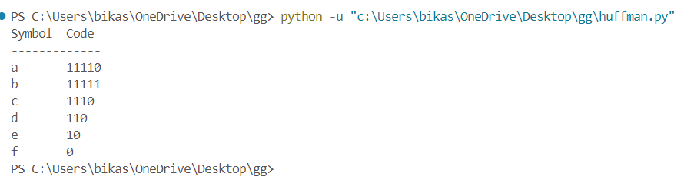

Conclusion:
In conclusion, the implementation of Huffman Coding successfully demonstrated how character frequencies can be used to construct an optimal binary tree for efficient data compression. By using a priority queue to build the tree and assigning shorter codes to more frequent characters, we achieved a prefix-free binary encoding scheme. This lab not only reinforced the theoretical understanding of greedy algorithms and binary trees but also highlighted the real-world relevance of Huffman coding in file compression and digital communication. The practical experience gained through coding and testing the algorithm deepened our grasp of data structures and algorithmic efficiency.

